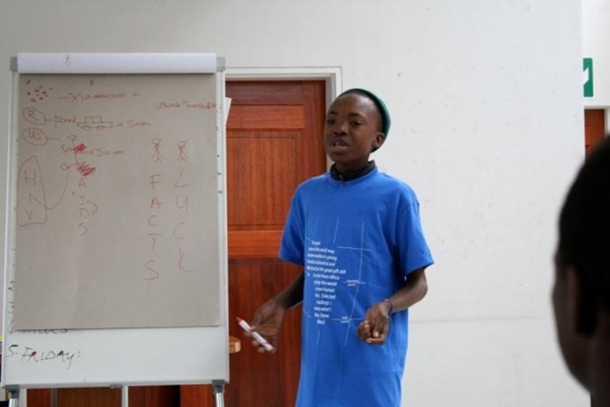
Figure 1
Figure 2
POA 2009, Sipo at Twilight Boys Home becomes a teacher of the module. Credit Dilara Uskup
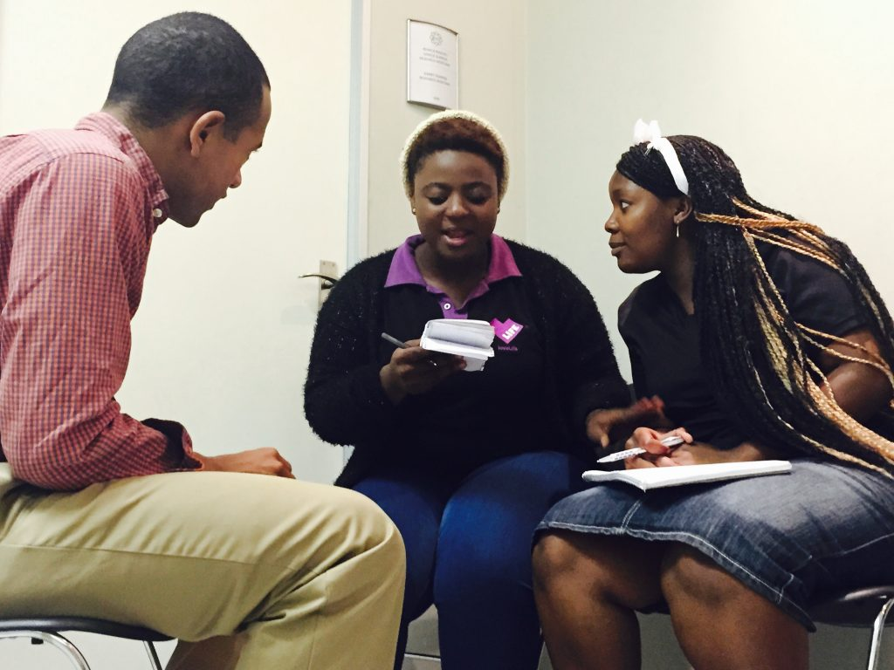
POA 2015, Ryan working with Phumi and Kerry-Ann at Lovelife credit Daniel C. Park
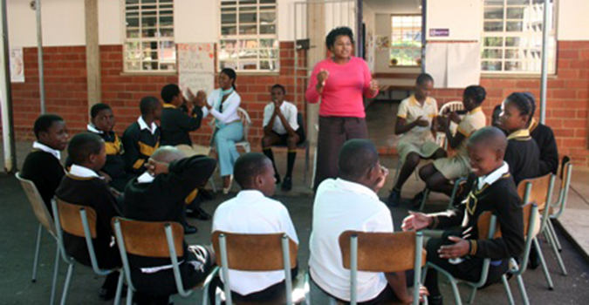
POA, 2006 Jessica Moorman and Jennifer chapman with 7th. Graders at Cato Crest Primary school, Cato Crest Durban Credit Ayana Richardson

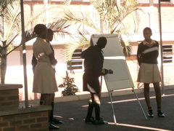
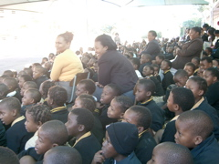
POA 2006, students trained in the HIV module teaching the entire school at Cato crest, Durban
Credit Ayana Richardson
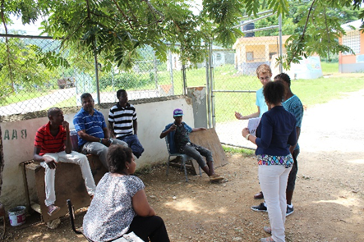
POA 2013, Aileen, Danetta and Carson teach under a tree in Saint Elizabeth, Jamaica credit Tyrell Collier
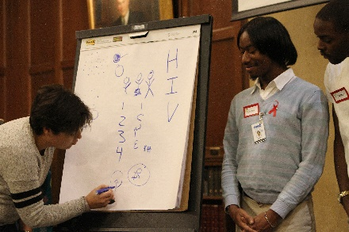
Mirna Haidar from the Z collective and Ervin Hollins from Horizons project, Detroit credit Ozi Oduma
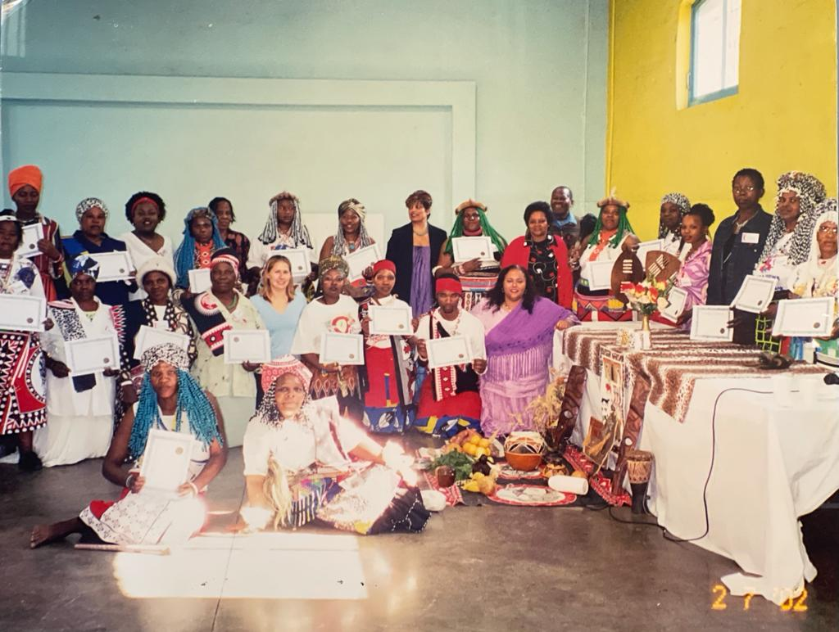
POA 2002, POA graduation with Traditional healers in Warwick Junction, Durban
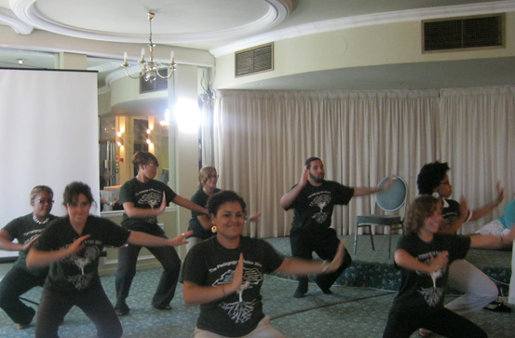
POA 2011, Performing Bollywood dance at POA graduation in Johannesburg, credit, Daisy Howlind

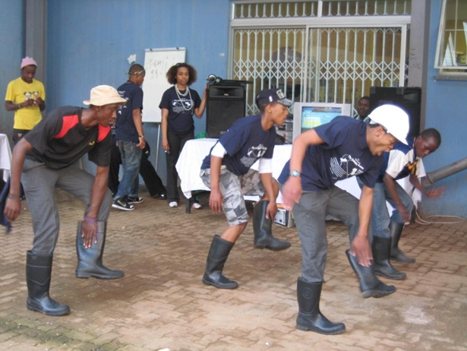
Twilight Boys home doing the gumboot dance for POA 2009
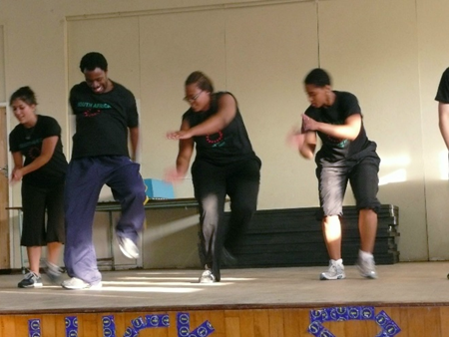
POA 2007, Rodney Brown, Erika, Zakiyah and Michaelyn rehearse Step
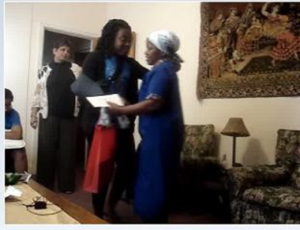
POA 2009, Kim giving a gift to Priscilla, a POA departure tradition at Rainsgrove Lodge, Durban credit Rocky Block

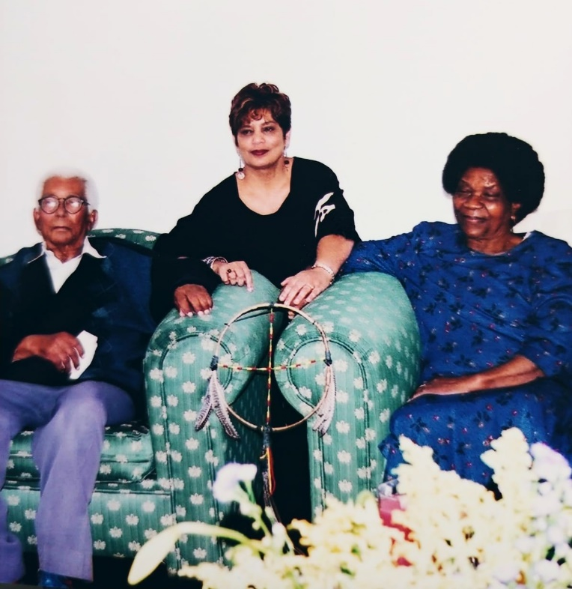
POA 2002, Nesha and her students had the honor of visiting with Walter and Albertina Sisulu
The father and mother of the new South Africa at their home in Johannesburg. Amandla!
Credit Fazela Haniff
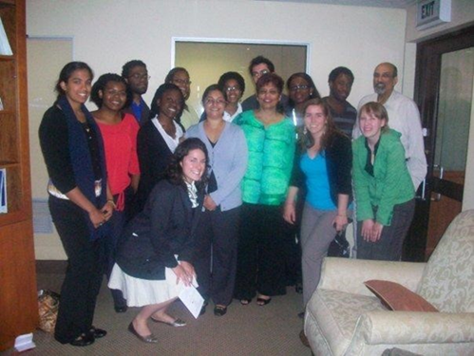
POA 2009 DR. Quarraisha Abdool Karim, and Dr. Salim Abdool Karim Science Directors
CAPRISA, the Center for the Aids Program for Research in South Africa
POA 2009 with John Kani eminent South African Playwright and actor
Credit Rocky Block

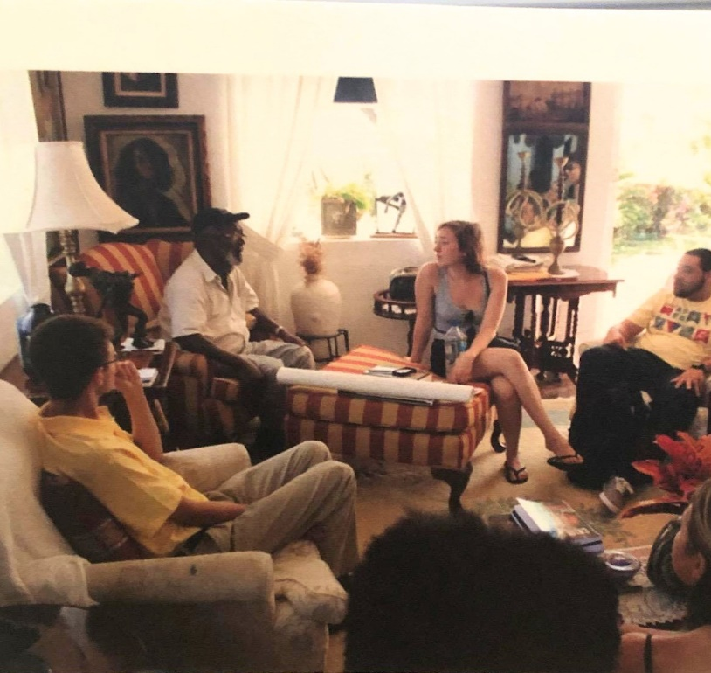
POA 2013 were welcomed to the home of Mr. Barrington Watson a world-renowned Jamaican artist. in Orange Park, St. Thomas Jamaica. Credit Tyrell Collier

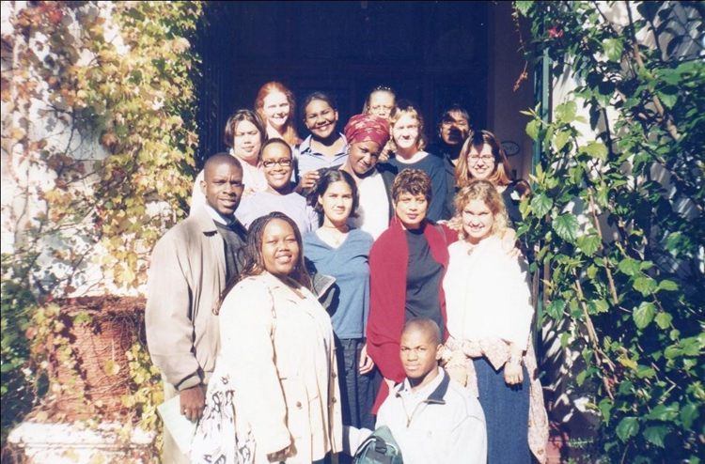
POA 2000, Capetown South Africa credit Leseliey Welch
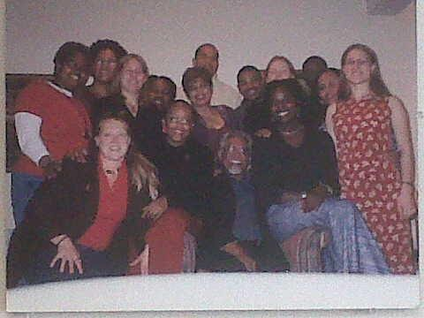
POA 2002, with Mac Maharaj apartheid struggle stalwart

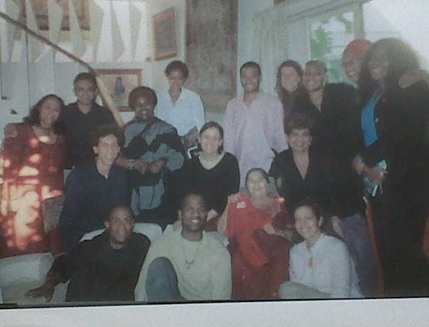
POA 2003 with Author Ashwin Desai and apartheid women’s struggle hero Fatima Meer
At Ms. Meer’s home in Durban credit Leseliey Welch
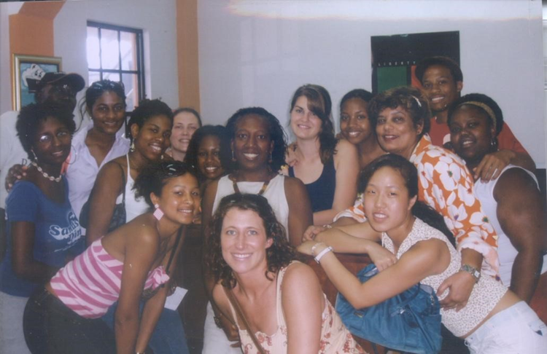
POA 2004, Marcus Garvey Museum with curator Dr. Donna McFarlane, Kingston, Jamaica
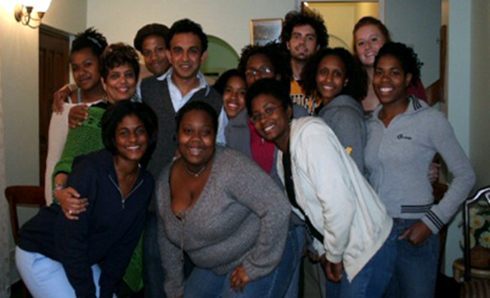
POA 2006, with Ashwin Desai author and activist, Durban

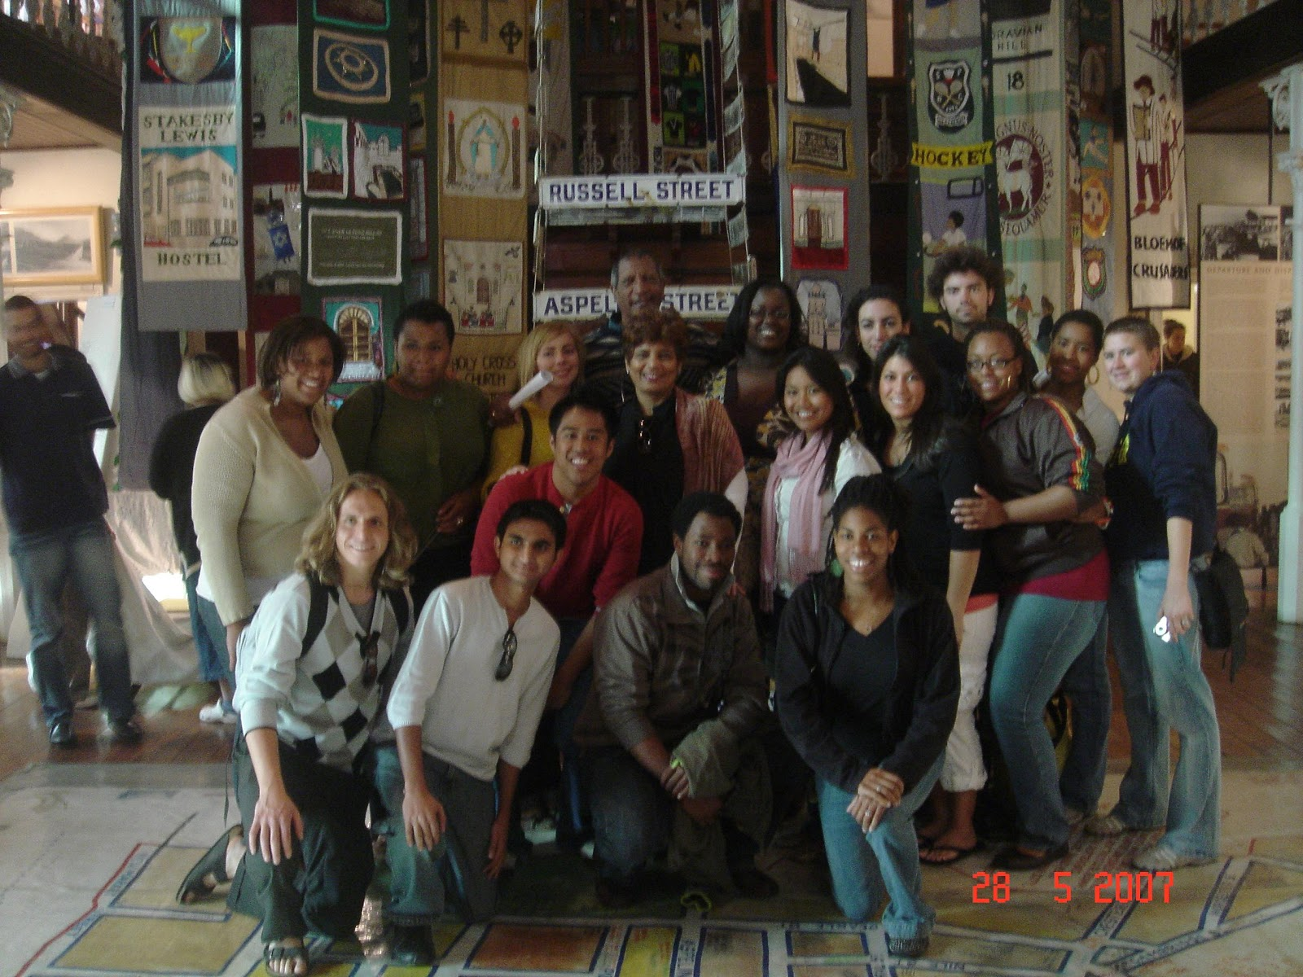
POA 2007, with Joe Schaffers telling the story of the District Six museum, in Capetown, credit Rocky Block

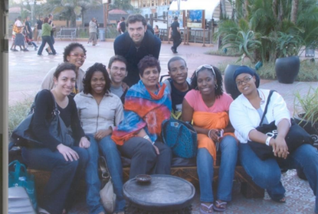
POA 2008 at Moyo Durban Credit Wynter McGruder
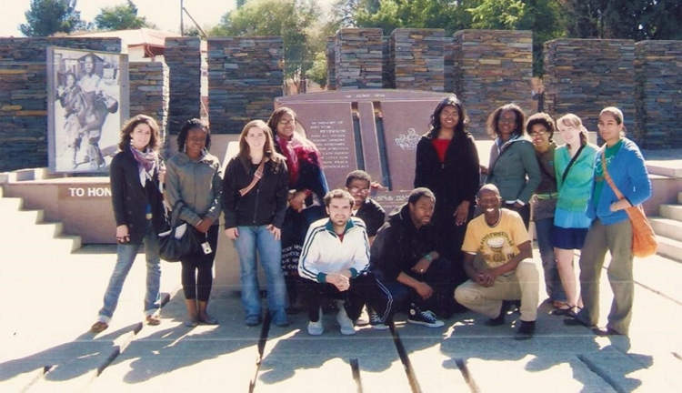
POA 2009 with Kenny our griot of Johannesburg at the Hector Pieterson museum, Soweto credit,
Rocky Block

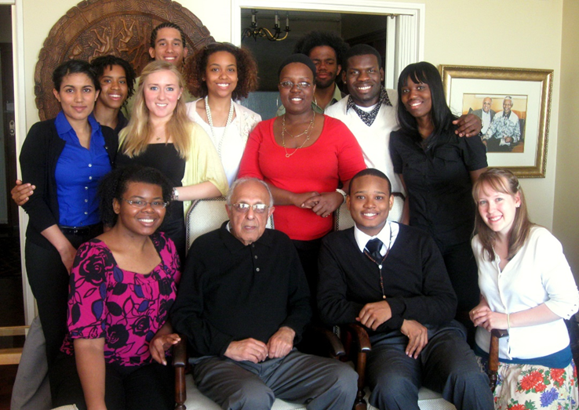
POA 2010 with Ahmad Kathrada at his home in Johannesburg,credit Kelsey Kennedy

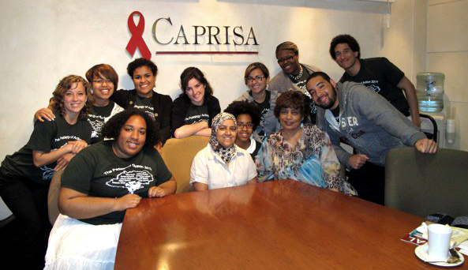
POA, 2011, at Caprisa, Center for the Aids Program for Research in South Africa, University of Kwazulu Natal, Durban, credit Daisy Howlind
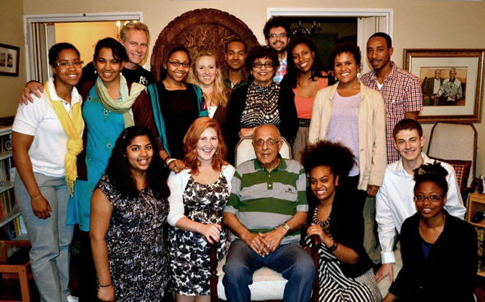
POA 2012 At Ahmad Kathrada’s home in Johannesburg, credit Porscha kazmierczak
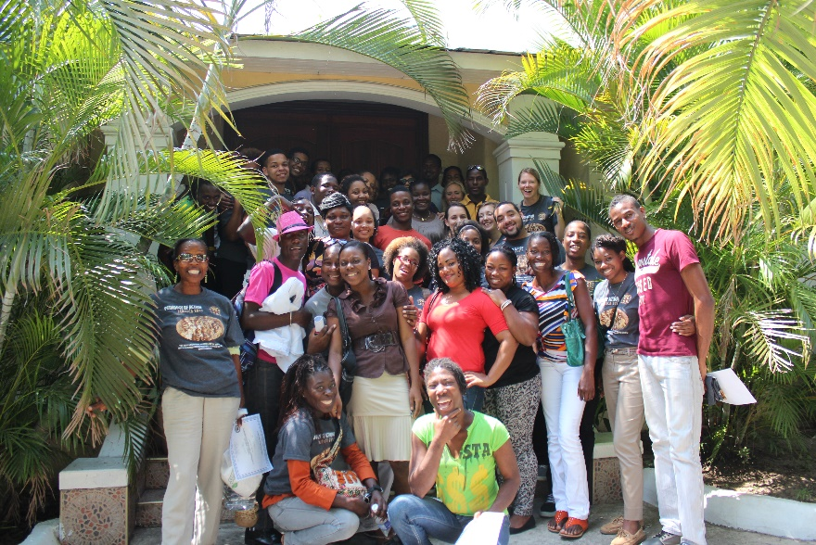
POA graduation with Ashe 2013, Kingston Jamaica credit Tyrell Collier

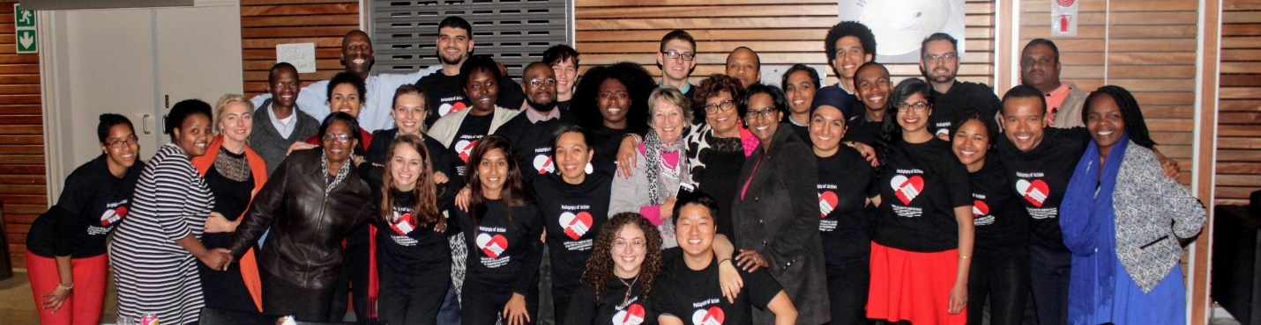
POA Symposium 2015, Durban credit Danny Park

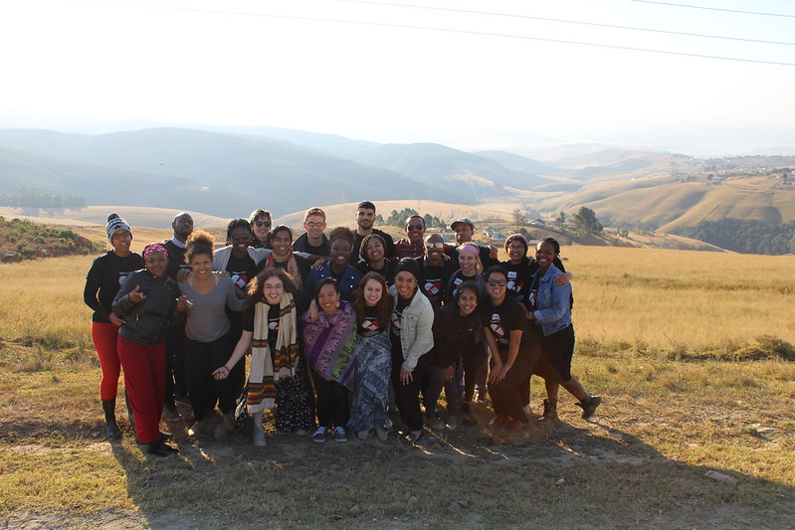
POA 2015, in the Hills of Vulindlela, Kwazulu Natal credit Danny Park

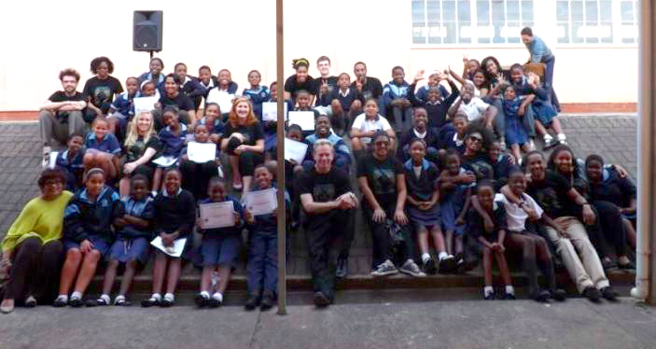
POA 2012 with students who taught the Module Charles Hugo Primary, Durban credit Rocky Block

