Profiles and Short Biography of CAAS/DAAS Leadership (1970 – till date)

Acklyn Lynch is a distinguished scholar, activist and expert on international economics. He was born in the twin island nation of Trinidad and Tobago and enrolled at Howard University in 1957, three years ahead of fellow Trinidadian-American and Civil Rights activist Stokely Carmichael. After graduating from Howards, he pursued graduate study first at Harvard University and then at Johns Hopkins University in the early 1960s. He then worked for a number of years on Wall Street before returning to academia in the late 1960s. Dr. Lynch has been a professor of Africana Studies at Howard University, University of Massachusetts, University of Michigan and University of Maryland Baltimore County where he served as Chair of the Department of Africana Studies. He has written numerous articles and books, including are “Nightmare Overhanging Darkly: Essays on African American Culture and Resistance” (Third World Press, 1993), “Riffing on a Blue Nite” (Afrikan World Books, 2017).

Acklyn Lynch (1970)
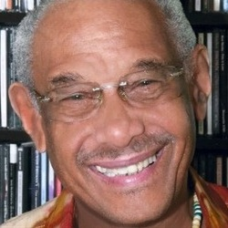

Born in Memphis, Tennessee, Professor Frank Yates received his A.B., Psychology degree (1967) and his M.A. in psychology (1969) from the University of Notre Dame. He then received his Ph.D. in psychology from the University of Michigan (1971). He joined the University of Michigan faculty as a lecturer in 1969 and was promoted to Assistant Professor upon completion of his doctorate in 1971. As a graduate student at the University of Michigan in 1970, Dr. Yates wrote a proposal for the Black studies center, which would become CAAS. He later became the acting Director of CAAS (1971-72), as an advanced graduate student. Dr Yates was named Associate Professor (1977), Professor of Psychology (1986), and Professor of Business Administration (1997) at the University of Michigan. In 1988, he was named Arthur F. Thurnau Professor of Psychology. Some of his groundbreaking publications include Judgement and Decision Making (1990); Risk-Taking Behavior (1992); and Decision Management: How to Assure Better Decisions in Your Company (2003). He is a co-founder of the Journal of Behavioral Decision Making. His research area includes cognition and cognitive neuroscience, and judgement and decision processes with emphasis on cross-cultural variations. Dr. Yates’ many honors include being named a Woodrow Wilson Fellow (1967-68), National Science Foundation Fellow (1967-69), American Psychological Association Fellow, American Psychological Society, and James McKeen Cattell Fellow (2011). In 2017, Dr. Yates was named to the American Academy of Arts and Sciences. Professor Yates retired from active faculty status on May 31, 2020 and has been named by UM Regents as Arthur F. Thurnau Professor Emeritus, Professor Emeritus of Psychology, and Professor Emeritus of Business Administration.
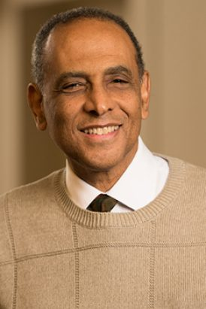
Frank Yates (1970-71)

Harold Cruse was born on March 8, 1916, in Petersburg, Virginia and educated in the public schools of Petersburg and New York City. During the Second World War, he joined the U.S. Army and studied journalism at the Armed Forces Institute (1941-42). In the Army, Professor Cruse served in Northern Ireland, Scotland, England, North Africa, and Italy. After his military service, he took a series of positions in public service, journalism, community affairs and has contributed to a variety of American and European publications, including New Leader and Negro Digest, among others. Professor Cruse came to the University of Michigan as a visiting professor in 1968 and was promoted to Professor of History and of Afro American and African Studies in 1977. His work at the University of Michigan in the late 1960s was vital to the development of the Center for Afroamerican and African Studies and he was subsequently appointed Director of the Center (1972-73). Professor Cruse’s publications The Crisis of the Negro Intellectual (1967) and Rebellion or Revolution? (1968) have influenced generations of historians and social critics. He was one of the first African-American studies professors to earn a tenureship without completing a college degree. Professor Cruse retired from active faculty status on May 31, 1984 and was named by Professor Emeritus of History and Afroamerican and African Studies by the University of Michigan. He died on March 25, 2005, in Ann Arbor, Michigan.
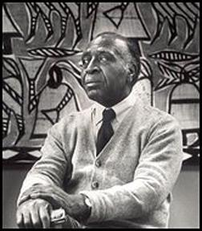
Harold Cruse (1972-73)

Leslie Owens is an Associate Professor Emeritus at Stony Brook University, Department of Africana Studies. He received his Ph.D. from the University of California, Riverside. Professor Owens served as the director of CAAS at the University of Michigan.

Leslie Owens (1973)

Ozzie Edwards was born February 16, 1936, in Cook County, Illinois. A graduate of St. Anne High in Illinois (1954), he served as an assistant minister at the Hope Bible Church on Chicago’s Southside, while attending Moody Bible Insititute (1957). He received his B.A. degree in Sociology from Wheaton College (1958) and two M.A. degrees in Social Work at the University of California (1963) and Sociology at the California State University (1964). He then received his Ph.D. in Sociology from the University of Wisconsin. Professor Edwards, a pastor and scholar, was the director of CAAS from 1973 to 1978. CAAS alumnus and University of Michigan Professor Phil Bowman credited Professor Edwards with stabilizing CAAS after the initial years of “churning” leadership. After his time at Michigan, Professor Edwards served as Director of Urban Studies at the Harvard Graduate School of Education and Director of African American Studies at Northeastern University, Boston. He has published several articles on sociology and written several articles for Christian publications, including quarterly Sunday School lessons for Urban Ministries, and literature designed for inner city youth. He was also the director of Imani Institute – a private school where students learn about their African heritage. He became Pastor at Eliot Church in Roxbury, MA in 1981 and served there for over two decades. Professor Edwards has received numerous awards and honors including a Doctor of Humanities Degree from the New England School of Law, and the Boston Neighborhood Fellows award for community service (1995). He died on April 3, 2002, in Boston.

Ozzie Edwards (1973-78)

Born in Mombasa, Kenya on February 24, 1933, Professor Ali Mazrui was known for his prolific writings on African politics and religion, Pan-Africanism, and colonialism. He received his B.A. degree from Manchester University in England (1960), M.A. degree from Columbia University in New York (1961), D.Phil. from Oxford University (Nuffield College, 1966), and spent the first ten years of his academic career on the faculty at the University of Makerere in Uganda (1963-73). Professor Mazrui came to the University of Michigan as a professor of Political Science in 1974, while also holding a professorship at the University of Jos in Nigeria. During his time at the University of Michigan, he was appointed Director of the Center for Afroamerican and African Studies (1978-81), where he worked to strengthen connections between African Studies and African American Studies. Professor Mazrui has written more than 30 books. Among his best known publications are Towards a Pax Africana (1967), The African Condition: A Political Diagnosis (1980), Black Reparations in the Era of Globalization (2002), and The African Predicament and the American Experience: A Tale of Two Edens (2003). His honors include the Association of Muslim Social Scientists UK (AMSS UK) Lifetime Academic Achievement Award (2000). He founded and directed the Institute of Global Cultural Studies (Binghamton University, 1991). Professor Mazrui died on October 12, 2014 in Vestal, New York.
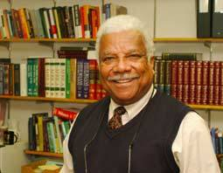
Ali Mazrui (1978-81)

Niara Sudarkasa was born on August 14, 1938, in Fort Lauderdale, Florida. She earned a Bachelor’s degree in Anthropology and English from Oberlin College in 1957 and went on to earn a Master’s degree (1959) and a Ph.D. (1961) in Anthropology from Columbia University. Professor Sudarkasa became the first African-American woman to teach at Columbia University while she earned her Ph.D. She was then the first African American woman to be appointed Assistant Professor of Anthropology at New York University (1964). Professor Sudarkasa came to the University of Michigan as a faculty member in the Department of Anthropology in 1967, becoming the first tenured African-American woman in the department in 1969. In 1972, she became the youngest scholar elected to the board of the American Anthropological Association. And, In 1981, she became the first woman appointed Director of the Center for Afroamerican and African Studies (CAAS). After departing the University of Michigan, Professor Sudarkasa was named the first woman President of Lincoln University, Pennsylvania. She has authored numerous works, including The Strength of Our Mothers: African And African American Women in Families, Where Women Work: Yoruba Traders in the Marketplace and in the Home, and Exploring the African American Experience. Professor Sudarkasa was awarded thirteen honorary degrees throughout her career. She died on May 31, 2019 in Fort Lauderdale, Florida.
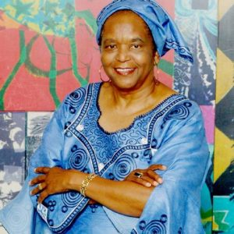
Niara Sudarkasa (1981-84)

Born on November 30, 1942, in Danvielle, Virginia, Thomas Holt received his B.A. (1965) and M.A. (1966) from Howard University. He began teaching at Howard in 1972, while earning his Ph.D. in American Studies from Yale University (1973). A scholar of the African Diaspora in the American South and Caribbean, Professor Holt joined the University of Michigan as a Professor of History in 1979 and served as the Director of CAAS from 1984 to 1986. Professor Holt’s works including Black Over White: Negro Political Leadership in South Carolina during Reconstruction (1979), The Problem of Freedom: Race, Labor, and Politics in Jamaica and Britain, 1832-1938 (1992), and The Problem of Race in the 21st Century (2000). Professor Holt was appointed to the Council of the National Endowment for the Humanities in 1994 and elected a member of the American Philosophical Society in 2016. He has received fellowships from the John Simon Guggenheim Foundation and the Woodrow Wilson International Center (1987-88). Professor Holt is currently the James Westfall Thompson Professor of American and African American History at the University of Chicago.
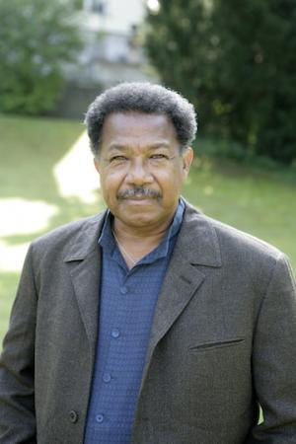
Thomas Holt (1984-86)

Lemuel Johnson was born December 15, 1941 to Sierra Leonean parents in Maiduguri, Nigeria. In 1960, he earned the highest marks in all West Africa on the Cambridge University Higher School Certificate examinations. Professor Johnson received his A.B. degree in Modern Languages from Oberlin College (1965), his M.A. in Spanish from Pennsylvania State University (1969). He received his Ph.D. in Comparative Literature from the University of Michigan in 1968 and was named Assistant Professor of English at the University of Michigan the same year. A scholar of the African Diaspora in American, Latin American, Caribbean, and African literature, Professor Johnson is the author of a three-volume work of poems titled the Sierra Leone Trilogy, as well as critical works The Devil, the Gargoyle, & the Buffoon: The Negro as Metaphor in Western Literatures (1970) and Shakespeare in Africa & Other Venues: Import and the Appropriation of Culture (1998). Professor Johnson held visiting appointments at the Colegio de Mexico, Mexico City, the University of Sierra Leone, the Salzberg Seminar, and Oberlin College. He was elected President of the African Literature Association (1977-78), Vice President of the Association of Caribbean Studies (1983-85), served on the Social Science Research Council’s Africa Committee (1985-90), and was appointed as the Director of CAAS (1986-90). He died in Ann Arbor on March 12, 2002.

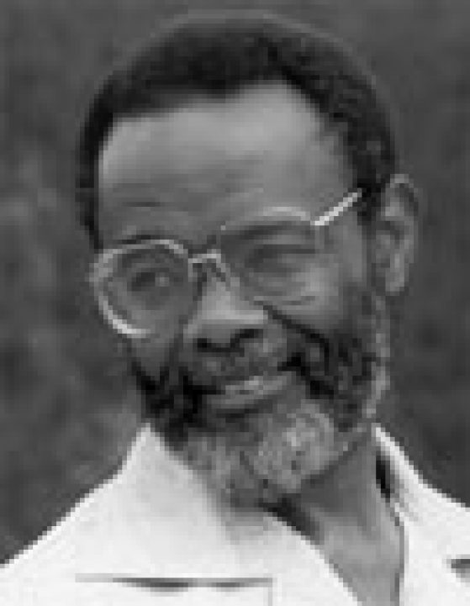
Lemuel Johnson (1986-90)

Born on November 15, 1955, in Norfolk, Virginia, Earl Lewis attended Concordia College in Moorhead, Minnesota, where he received his B.A. degree in history and psychology (1978). He then received his M.A. (1981) and Ph.D. (1984) in history from the University of Minnesota. He began his teaching career as an Assistant Professor in the department of African American Studies at the University of California, Berkeley (1984), then joined the University of Michigan as an Associate Professor of History and Afroamerican and African Studies in 1989. He was later appointed as the Director of CAAS (1990-93) and was named Professor of History and African American and African Studies in 1995. Professor Lewis was appointed Dean of Rackham School of Graduate Studies (1997), Vice Provost for academic affairs/graduate studies (1998), and appointed as the Elsa Barkley Brown and Robin D.G. Kelley Collegiate Professor of History and African American and African Studies (2003). He later joined the faculty at Emory University as the Asa Griggs Candler Professor of History and African American Studies and became Emory’s first African-American provost in 2004. He was the highest-ranking African-American administrator in the university’s history. Professor Lewis returned to the Univsersity of Michigan in [year] after serving as President of the Andrew W. Mellon Foundation. He is the author and coeditor of nine books on the role of race in American history, diversity, equity and inclusion, and graduate education. Professor Lewis is the recipient of eleven honorary degrees, a recipient of the University of Michigan’s Harold R. Johnson Diversity Service Award, a member of the Council on Foreign Relations, and a fellow of the American Academy of Arts and Sciences (2008). He was recently honored with the College of Liberal Arts Outstanding Alumni Award from the University of Minnesota (2018). He is currently back at U-M as the founding director of the Center for Social Solutions.

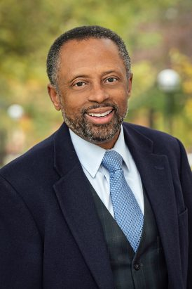
Earl Lewis (1990-93)

A native of Philadelphia, Michael Awkward was born on May 6, 1959. He graduated cum laude from Brandeis University (1980) and receieved his M.A. (1982) and Ph.D. (1986) from the University of Pennsylvania. Professor Awkward began his career as the Gayl A. Jones Professor of Afro-American Literature and Culture at the University of Michigan (1986) and achieved tenure in 1990. He was named Director of CAAS in 1993 and Professor of English and Afro-American and African Studies in 1995. Professor Awkward’s areas of specialization include 20th century Black American literature, especially post-World War II; the impact of gender on the study of Black American expressive culture; and Black American autobiography as well as contemporary American autobiography. His scholarly works include Burying Don Imus: Anatomy of a Scapegoat; Philadelphia Freedoms: Black American Trauma, Memory, and Culture after King; Negotiating Difference: Race, Gender and the Politics of Personality, andScenes of Instruction: A memoir. Professor Awkward has taught at Emory University and University of Pennsylvania, where he became the director of English (2000). He returned to the University of Michigan in [year] as Professor of English Language and Literature.
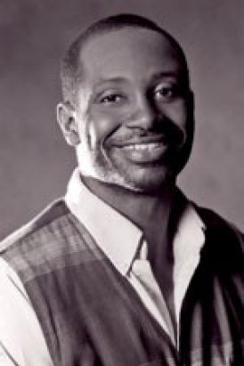
Michael Awkward (1993-96)

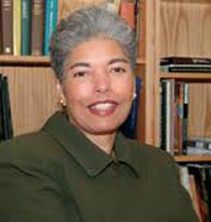
Sharon Patton (1996-98)
Born in South Side Chicago in 1944, Sharon Patton attended Roosevelt University in Chicago where she earned a B.A. Magna Cum Laude in humanities, with a concentration in studio art (1966). She received her M.A. from the University of Illinois, Champaign-Urbana (1969), then continued her education at the University of Chicago, then Northwestern University, where she received her Ph.D. in the History of African Art (1980). Professor Patton began her teaching career at Mankato State College (1968) and served on the faculties of Lake Forest College (1971), the Virginia Commonwealth University (1972), and the University of Houston (1976). She then joined the University of Maryland as an Assistant Professor in the Art Department in 1979. Professor Patton became the Director of Art Galleries at Monclair State College in 1986 and Chief Curator of the Studio Musuem in Harlem, New York in 1987. She moved to the University of Michigan as an Associate Professor in History of Art and African-American and African Studies (1991) and became the Director of CAAS in 1996. She was named John G.W. Cowles Director of Oberlin College’s Allen Memorial Art Museum (1998) and was appointed as the Director of the Smithsonian’s National Museum of African Art (2003). As an American Historian who specializes in African Art, Patton has organized nearly 20 exhibitions. Three of Professor Patton’s works are mounted in the Studio Museum in Harlem, having received much critical acclaim: “Memory and Metaphor, the Art of Romare Bearden, 1940-1987”; “Home: Contemporary Urban Images by Black Photographers”; and “The Decade Show: Frameworks of Identity in the 1980s.” Professor Patton, a prolific writer, has been the recipient of numerous grants, awards, and fellowships.

A native of Detroit, Michigan, James Jackson was born on November 25, 1944. He attended Michigan State University with the intention of becoming an engineer, but found his calling in Pyschology, earning a B.S. degree in Psychology in 1966. He received his M.A. in Psychology from the University of Toledo (1970) and his Ph.D. in Social Psychology from Wayne State University (1972). Professor Jackson joined the faculty at University of Michigan as an Assistant Professor in 1971, was named Associate Professor in 1977, and Professor of Psychology in 1986. He is recognized worldwide for his studies on race relations and disparities in minority health. He is the Founding Director of the Program for Research on Black Americans (PRBA), serving for over 40 years. PRBA is devoted to understanding racial and ethnic influences on physical and mental health of Black populations. He was named Director of CAAS in 1998 and led the Center until 2005. Professor Jackson was named a Fellow of the American Association for the Advancement of Science (AAAS) in 2005, received the James McKeen Cattell Fellow Award from the Association for Psychological Science (2006), and was recognized with an Investigator Award from the Robert Wood Johnson Foundation (2009). He was named President of the Society for the Psychological Study of Social Issues in 2010. Professor Jackson retired from active faculty status on May 31, 2020 and has been named Daniel Katz Distinguished University Professor Emeritus of Psychology, Professor Emeritus of Psychology, and Research Professor Emeritus, Research Center for Group Dynamics, at the University of Michigan..
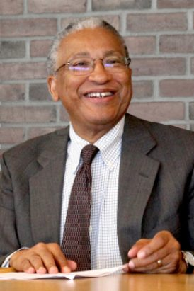
James Jackson (1998-2005)

Kevin Gaines received his B.A. degree in Political Science and Government from Harvard University in 1982 and continued his education at Brown University, where he received his M.A. in Government (1987) and Ph.D. in American Civilization (1991). He started his teaching career at Princeton University as an Assistant Professor in 1991 and joined the University of Michigan as an Associate Professor in 1999. Professor Gaines was named Professor of History and Afroamerican and African Studies in 2005 and served as Director of CAAS from 2005 to 2010. He was named Robert Hayden Collegiate Professor of History and Afroamerican and African Studies in 2010. He has authored numerous works, including Uplifting the Race: Black Leadership, Politics, and Culture During the Twentieth Century (1996), American Africans in Ghana: Black Expatriates and the Civil Rights Era (2006) and has received numerous awards for his scholarship. As director of CAAS, Professor Gaines oversaw the Center’s transition to an academic department (DAAS) and oversaw an ambitious phase of hiring and promotion that included the promotion of seven women to the position of full professor. Professor Gaines was appointed as the W.E.B. Du Bois Professor of Africana Studies and History at Cornell University in 2015 and was subsequently named the University of Virginia’s inaugural Julian Bond Professor of Civil Rights and Social Justice.
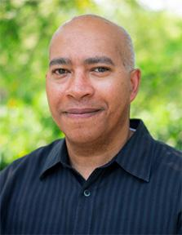
Kevin Gaines (2005-10)

Born in Detroit, Michigan, in 1965, Angela Dillard earned a B.A. in Justice, Morality, Constitutional Democracy from James Madison College, Michigan State University in 1988. She then earned her M.A. in Political Science from the New School for Social Research in New York (1991), and Ph.D. in American Culture from the University of Michigan (1995). Professor Dillard then held faculty positions at the University of Minnesota and New York University, before joining the faculty at the University of Michigan in 2006. Professor Dillard is the Richard A. Meisler Collegiate Professor of Afroamerican & African Studies, History, and in the Residential College, where she is part of the Social Theory & Practice program. She specializes in American and African-American intellectual history, particularly around the issues of race, religion and politics. Professor Dillard has served as the Director of CAAS (2010-11), Director of the Residential College (2011), and Associate Dean of Undergraduate Education (2015) at Michigan. She is the author of Guess Who’s Coming to Dinner Now?: Multicultural Conservatism in America (2001), one of the first studies of political conservatism among marginalized groups in the United States, and Faith in the City: Preaching Radical Social Change in Detroit (2007), as well as many critical articles published in academic and popular journals. Professor Dillard is currently working on a political biography of James H. Meredith, the icon of the civil rights movement turned conservative Republican. She has recently launched The Black Church Project – an initiative involving churches in Detroit and Ann Arbor, serves on the Executive Committee for the Bentley Library, and was appointed to the State of Michigan’s Freedom Trail Commission.
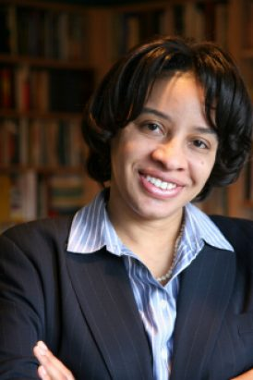
Angela Dillard (2010-11)

Born on January 17, 1970, in Cincinnati, Ohio, Tiya Miles attended Harvard University, where she received an A.B. degree in Afro-American Studies in 1992. She went on to receive a M.A. degree in Women’s Studies from Emory University (1995), and a Ph.D. in American Studies from the University of Minnesota (2000). Professor Miles began her teaching career at the University of California, Berkeley and joined the faculty of the University of Michigan as Assistant Professor in 2002. She was named Associate Professor in 2007, and Professor in 2011. Professor Miles was subsequently named Elsa Barkley Brown Collegiate Professor (2012) and Mary Henrietta Graham Distinguished University Professor (2015) at the University of Michigan. She served as Chair of the Department of Afroamerican & African Studies from 2011 to 2014, Director of the Native American Studies Program from 2007 to 2010 and founding Director of ECO Girls (Environmental & Cultural Opportunities for Girls in Urban Southeast Michigan) from 2011 to 2014. Professor Miles has authored five award winning books, Ties That Bind: The Story of an Afro-Cherokee Family in Slavery and Freedom; The House on Diamond Hill: A Cherokee Plantation Story; The Cherokee Rose: A Novel of Gardens and Ghosts; and Tales from the Haunted South: Dark Tourism and Memories of Slavery from the Civil War Era (a published lecture series). Professor Miles is a recipient of the MacArthur Foundation Fellowship Award (2011-16) and the Hiett Prize in the Humanities and Culture (2007). She has served as a volunteer consultant for the Eiteljorg Museum in Indianapolis and the Chief Vann House State Historic Site in Georgia. Professor Miles is currently a Professor of History and Radcliffe Alumnae Professor at the Radcliffe Institute for Advanced Study at Harvard University.
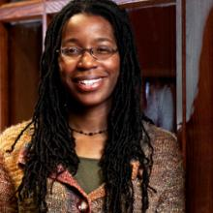
Tiya Miles (2011 – 2014)

Born in Cameroon, in 1959, and raised in Switzerland, Frieda Ekotto received her B.A. degree from Colorado University (1986), and her M.A. and Ph.D. in Comparative Literature from the University of Minnesota (1989 and 1994 respectively). Professor Ekotto joined the University of Michigan as an Assistant Professor of French and Francophone Studies, and Comparative Literature in 1994. She was named Associate Professor in 2000, and Professor of African Literature, Francophone Studies, and Comparative Literature in 2009. Professor Ekotto was the first African born woman to lead DAAS as the Chair of the department from 2014 to 2018. Her scholarship has been critical to the emergence of the study of race and ethnicity in the context of French-speaking cultures at the University of Michigan. As an intellectual Historian and Philosopher, her research and teaching focuses on contemporary issues of law, race, and LGBTQI issues. Professor Ekotto is the recipient of numerous grants and awards, including a Ford Foundation seed grant for research and collaborative work with institutions of higher learning in Africa, the Nicolàs Guillén Award for the Caribbean Philosophical Association (2014), the Benezet Award from the Colorado Alumni Association Board (2015), and was awarded the John H. D’Arms Faculty Award for Distinguished Graduate Mentoring in the Humanities at the University of Michigan (2016). Professor Ekotto is currently Professor of Afroamerican and African Studies and Comparative Literature at the University of Michigan.

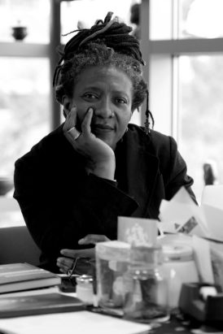
Frieda Ekotto (2014 – 2018)

A Philadelphia native, Matthew Countryman earned a B.A. degree in History from Yale University (1986), and a M.A. and Ph.D. in History from Duke University (1992 and 1999 respectively). He began his teaching career as an assistant professor of History and American Culture at the University of Michigan in 1998 and was named Associate Professor in 2005 Professor Countryman’s areas of research include African-American social movements; Race, postwar liberalism, and the American left; Public memory of the Civil Rights movement; and the social construction of race. Professor Countryman served as Faculty Director of the Arts of Citizenship Program, now called the Rackham Program in Public Scholarship, from 2007 to 2016. He is the author of the award-winning book, Up South: Civil Rights and Black Power in Philadelphia, a history of civil rights, black power, and black activism in postwar Philadelphia. Professor Countryman is well known for his commitment to equity, inclusion and mentorship across UM campus. His awards include the John H. D’Arms Faculty Award for Distinguished Graduate Mentoring in the Humanities, University of Michigan (2016), and a Charles Warren Center Fellowship, Harvard University (2008-09). Professor Countryman was named Chair of DAAS in 2018.
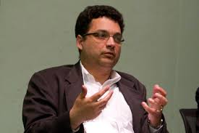
Matthew Countryman (2018 - )

